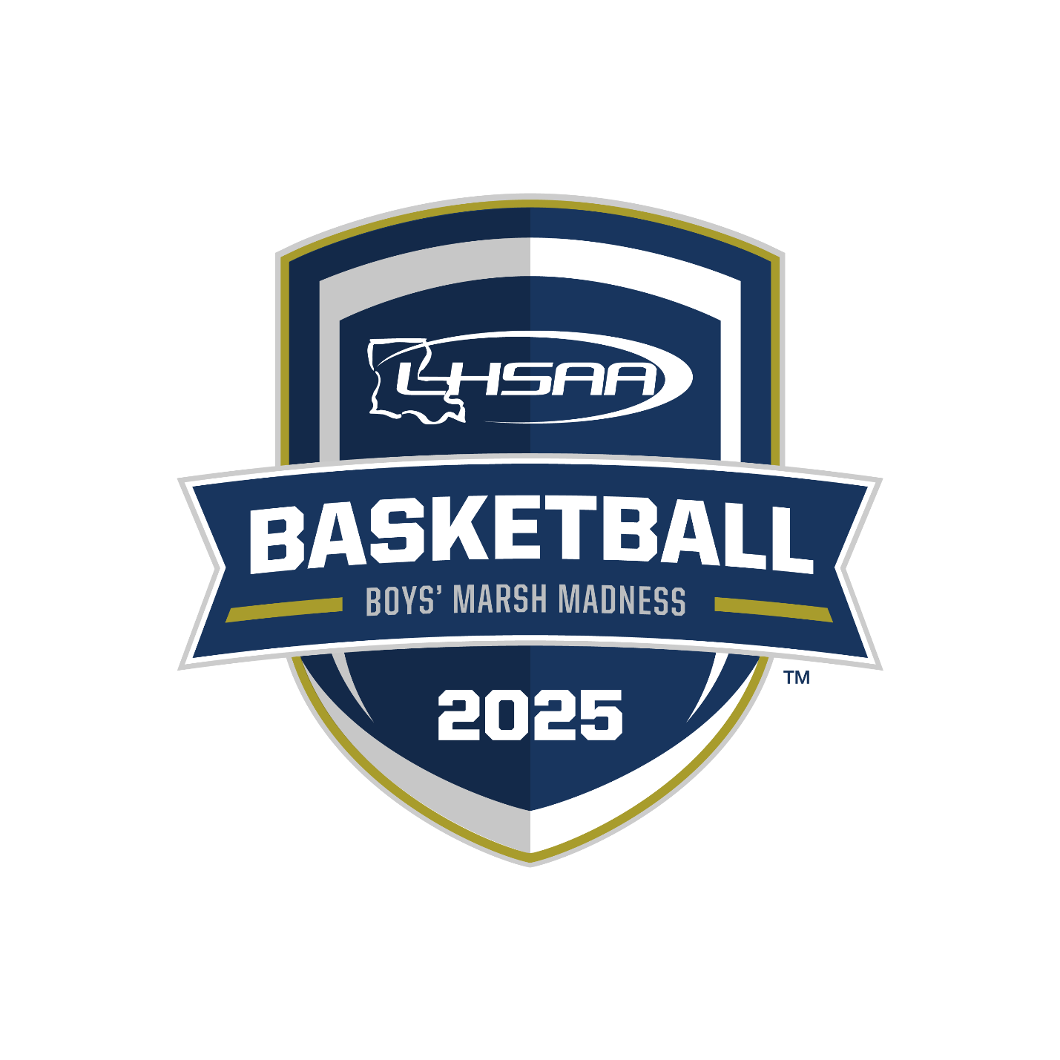

2025 LHSAA STATE
CHAMPIONSHIP BULLETIN
PLEASE CHECK BACK OFTEN FOR UPDATES!!
IT IS YOUR RESPONSIBILITY TO KNOW ANY/ALL LHSAA &
UNIVERSITY CENTER POLICIES BEFORE YOUR ARRIVAL.

table of contents

CONTENT | PAGE(S)
basketball important dates | page 1
general information | page 2
site information | page 3
all-academic, non-participating team, support groups, band information | pages 4
media information & yearbook information | page 5
marsh madness hotel information | pages 6
2024 - 2025 boys’ marsh madness site map | page 7
championship souvenirs | page 8
lhsaa sponsors | page 10

2024-25 basketball important dates

This Bulletin is for your benefit. Please read and make sure all necessary parties receive the correct information concerning the event.

DATE | EVENT
Boys – All Classes and Divisions:  Saturday, February 1, 2025 | Deadline to Add Games to Schedule for Power Rating Purposes
Boys – All Divisions:  Saturday, February 22, 2025 | End of Regular Season/District Representatives Named
Boys – All Divisions:  Monday, February 24, 2025 | Playoff Pairings Named/Brackets Released
Boys – All Divisions:  3:00 P.M. - Friday, February 28, 2025  (LHSAA Bylaws 6.13.6 & 11.10.4) | Deadline to submit team rosters online.  State Tournament Program Roster Submission Instructions  - Rosters submitted in any/all formats other than the provided format shall be disregarded and will not be included in the program. ZERO EXCEPTIONS!!

Boys’ Playoff Dates - All Divisions:

Bi- District Round Deadline – Friday, February 28, 2025
Regional Round Deadline – Tuesday, March 4, 2025
Quarterfinal Round Deadline – Friday, March 7, 2025
LHSAA Boys’ Marsh Madness

Monday, March 10, 2025 – Saturday, March 15, 2025
Burton Coliseum, Lake Charles, LA

2024-25 marsh madness championship
general information

This Bulletin is for your benefit. Please read and make sure all necessary parties receive the correct information concerning the event.

CATEGORY | DATE/INFORMATION
State Championship Dates and Site | Boys’ Non-Select Marsh Madness Championships:  March 10-15, 2025  Burton Coliseum, Lake Charles, LA
Tournament Director | Karen Hoyt  Assistant Executive Director, LHSAA  Email: khoyt@lhsaa.org  Phone: (225) 300-4215
Assistant to Tournament Director | S. Lacy Macdiarmid  Administrative Assistant, LHSAA  Email: lmacdiarmid@lhsaa.org  Phone: (225) 300-4208
Admission Per Session  Gates open 1 hour prior to each day | Tickets - $18.00 + facility fee & taxes  NOTE: A SESSION IS EQUIVALENT TO 1 DAY OF TOURNAMENT PLAY. THERE IS NO RE-ENTRY TO THE FACILITY ONCE YOU EXIT.
IMPORTANT  Burton Coliseum  Game Day 411 | To purchase tickets, click here.  Policies click here and Cashless Venue FAQ’s click here.
LHSCA Coaches Gate | West Ticket Gate of the Burton Coliseum.  ALL LHSCA/LHSAA CARDS ARE NON-TRANSFERABLE  CARDHOLDERS MUST BE PRESENT WITH A VALID PICTURE ID
Trainers/  Medical Personnel | Trainers will be provided for all games. Schools must bring their own tape and individual water bottles that do not conflict with LHSAA Partner Powerade.
Other | Teams will be required to bring individual water bottles that do not conflict with LHSAA Partner Powerade. Bottled water will be provided.  Official Game Ball – Perfection ElitePRO BX7E-PRO-00  2024-25 National Federation Basketball Rules and LHSAA Constitution, Amendments and Bylaws will be followed.

2024-25 marsh madness championship
site information

CATEGORY | DATE/INFORMATION
Team Dropoff & Entry  The roster bylaw will be strictly enforced. | South side of Coliseum under the covered walkway.  Each team will be allowed 24 personnel to enter. The 24 includes coaches, players in legal uniform, managers, trainers, and statisticians. Additional team personnel must purchase a ticket and enter through Main Gate. ZERO EXCEPTIONS!! (LHSAA Bylaw 11.10.4)  SEMI-FINALS ONLY - Team and individual pictures will be taken upon arrival your team’s arrival. GeauxPreps requests that all teams arrive in game uniform 1 hour and 30 minutes prior to game.  FINALS - Teams may enter the facility 1 hour prior to game.
Team Uniforms and Dressing Rooms | All teams shall arrive in GAME UNIFORMS and need to bring both sets of uniforms. Higher seed will be HOME team. Site Host Families will take you to your assigned locker rooms.  HOME – white jerseys VISITOR– dark jerseys
Team Roster  Information  (By-law 6.13.6 & 11.10.4) | Each team will be allowed 24 personnel to enter. The 24 includes coaches, players in legal uniform, managers, trainers and statisticians. Per LHSAA Bylaw 6.13.6, once a roster is submitted, it shall be considered final. No Exceptions!!
Participating Team Seating | Teams that arrive early and are waiting to play will sit in the following sections: HOME – Section 112 VISITOR – SECTION 104
Team Benches  (when facing score table) | Burton Coliseum: HOME – Right bench VISITOR – Left Bench
Pre-Game Warm-Up  Practice and game balls  will be provided | All teams warm-up on the opposite end of your team bench before each game. The 1st game of the session will be allowed 30 minutes prior to their game to warm-up. All other games will be allowed 15 minutes prior to their game.
Pre-Game Protocol | Semi-Finals: will only be done in the following order before the 1st game of that day. - Prayer, National Anthem, Player Introductions  Finals: done in the following order before each Championship game.  - Prayer, National Anthem, Game Ball Presentation, Player Introduction
Post-Game Interviews  (Failure to comply shall be penalized under By-law 5.11.14) | Coaches shall be responsible for the following:  - Attending the post-game interview session immediately following their game.  - Ensuring any/all players, requested by media, attends the post-game interview session immediately following their game.

2024-25 all-academic, NON-PARTICIPATING TEAMs, & Support group information

CATEGORY | DATE/INFORMATION
All-Academic Recipients | Your student will be recognized by printing the certificate and honoring the student at your sports award banquets. If you have any questions, please contact Renee’ Ballard at rballard@lhsaa.org
Non-Participating Teams | Any team that has played a semi-final game and is no longer participating in the tournament shall be accompanied by their head coach and enter together at the South side of Coliseum under covered walkway to enter free of charge.
Spirit Groups &  Half-Time Performance Information | All Spirit (cheer/dance/pep/etc.) sponsors and/or uniformed participants, SHALL enter together when checking in at the South side of Coliseum under the covered walkway to enter free of charge. The LHSAA will count and invoice member school $18.00 each for any/all additional Spirit (cheer/dance/pep/etc.) sponsors and/or participants over 25.  Any/all music for all half-time performances shall provide music on iPad, iPhone, etc. as well as any/all necessary adapters. NO MATS OR STUNTING ALLOWED!
Bands | Any and all Band Directors and/or members SHALL enter together when checking in at the South side of Coliseum under the covered walkway, will be counted and your school invoiced $18.00 each for every Director, Sponsor and/or Member. Band directors, sponsors and/or members without instruments and/or not or in uniform shall purchase full tickets and enter through spectator entrance.  Home Section: 211 Visitor Section: 205
Participating School Supervision & Responsibilities | Schools shall be responsible for including but not limited to the following:  - LHSAA Bylaws 3.1.1(1-4) & 3.1.3  - Informing all their athletes, students, fans, etc. of any/all LHSAA and/or Burton Coliseum prohibited items, policies, etc.  - Any and all actions and/or behavior of all their athletes, students and/or fans etc.  Failure to do so shall result in the offending school being fine. (LHSAA Bylaw 5.11.11)
Signs and Decorations | Decorations and signs are permissible; however, they must:  - Be in good taste and illustrate good sportsmanship.  - Be on paper or cardboard and may have shiny surface.  - Be hung using blue tape on any and all surfaces. No duct tape or scotch tape.  - Schools shall be responsible for informing their boosters, fans and/or support groups.
Prohibited Items  & Policies | Prohibited items’ information can be found on the links below:  Burton Coliseum Policies  Official LHSAA Online Handbook  All unauthorized items will be taken and can be picked upon the completion for contest.

2024-25 MEDIA/SCHOOL YEARBOOK

(Please read the LHSAA Media Policy found on the LHSAA Website)
CATEGORY | DATE/INFORMATION
Media &  School Yearbook | - STUDENT media credential candidates must complete the same electronic credential application as the professional media. This application can be found on the website.  LHSAA.org > News & Media > Credentials Tab > Media Credential Application-FALL  - The individuals submitted by an LHSAA member school must submit a proper STUDENT ID to receive credentials to enter the state championship. Faculty members WILL NOT be credentialed. Only student media will be allowed in with an approval letter from their principal and with a faculty member accompanying them as a chaperone. Please review the updated school media policies on our website. School media policies can be found on page six.  LHSAA.org > News & Media > Credentials Tab > Media Policies & Procedures  - If a school media department would like to request state championship/semi-final photographs for yearbook/media purposes, please email Michael Odendahl of GeauxPreps (bigshock77@yahoo.com) for five COMPLIMENTARY state championship/semi-final photos. Photographs shall be limited to only the school's team members while in competition.  *School media members will not be permitted on the field/court during post-game celebrations. *
Radio/Internet Broadcasting  & Game Video | - Fee per game/match - $150  - Stations broadcasting will be responsible for charge to originating point.  - All Rounds will broadcast live by and through the NFHS Network. (www.nfhsnetwork.com).  - Live streaming is strictly prohibited during the entire tournament as they are available on the NFHS Network.

2024-25 hotel information

CATEGORY | INFORMATION
Hotel Supervision | - Teams must be supervised at all times! The school will be responsible for any damage to assigned rooms or hotels and their property.
Hotel Booking Procedures | - Information posted will be posted below as the LHSAA receives it.  - Schools are responsible for securing their own hotel accommodations.  - All reservations are to be made by the individual teams at the hotel of your choice.  - All reservations will be accepted on a first come, first serve basis.  - All rooms must be guaranteed. Please supply credit card information at the hotel of your choice.  - When calling the hotel, please tell them that you are with the LHSAA to receive the discounted rate.  - All cancellations should be made directly with the hotel.
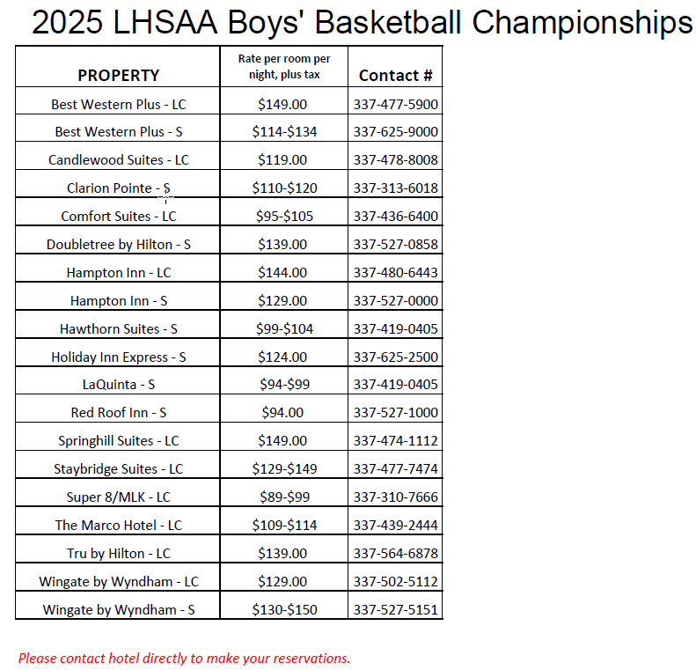

2024-25 site map

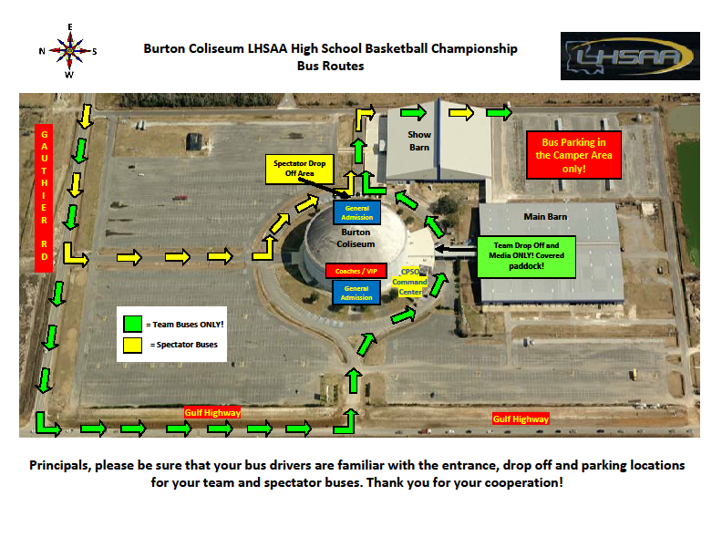
Burton Coliseum Map – Lake Charles, LA

2024-25 CHAMPIONSHIP SOUVENirs

CHAMPIONSHIP APPAREL   | Remember this achievement. Visit the PepWear Store or shop.lhsaa.org to purchase Official Event Merchandise including shirts and hoodies with participants’ names on the back, full color plaques, and more!  For assistance with orders contact  (866) 775-3450 or  customerservice@pepwear.com
Championship photographs   | GeauxPreps is proud to be the official photographer of the Louisiana High School Athletic Association. Please stop by our booth during all of the  LHSAA Championships to view and order photos. Team and individual, action, and all awards photos will be available for purchase and will be printed on site.  https://geauxpreps.com/photos/
Championship rings | Congratulations champions! Celebrate your victory with your championship ring- the ultimate symbol of dedication, perseverance and teamwork. Herff Jones is proud to be the exclusive provider for LHSAA and LHSCA Championship Jewelry and is the recognized leader in celebrating student milestones.  Harris Beall, Clint Ivey, Donald Scamardo  Baton Rouge, LA // 225.927.1383 // gshhbrla@gradsupply.biz  Metairie, LA // 504.737.4439 // gradsupply@aol.com
Championship replica trophies   | For more information regarding State Championship mini replica trophies and medals, contact  Gold Star Trophies at (225) 928-4230.  www.goldstartrophies.com

2024-25 LHSAA SPONSORS

