***LOUISIANA HIGH SCHOOL ATHLETIC ASSOCIATION***

**2024-25 Softball General Information Bulletin**

table of contents

|  |  |
| --- | --- |
| **CONTENT** | ***PAGE(S)*** |
| table of contents | page 1 |
| general information/district scheduling meeting/out of state requirements/2024-2025 lhsaa sponsors | Pages 2-3 |
| instructions for head coach taking mandatory online rules clinic | Page 4 |
| instructions for entering softball schedules into lhsaa member site | Page 5 |
| instructions for entering played games /confirming a game | Page 6 |
| editing playoff brackets | page 7 |
| entering playoff game results | page 8 |

2024-25 SOFTball general information

*This Bulletin is for your benefit. Please read and make sure all necessary parties receive the correct information concerning the event.*

|  |  |
| --- | --- |
| **CATEGORY** | **DATE/INFORMATION** |
| LHSAA Softball Bylaws | Completely familiarize yourself with Section 19 as well as all necessary sections of the 2024-2025 Handbook and section. The Handbook and each section can be found on [www.lhsaa.org](http://www.lhsaa.org). |
| First Official Practice/Earliest Scrimmage Allowed | All Classes & Divisions – Monday, January 20, 2025 |
| Jamboree and Tournament  Dates and Information | **All Classes and Divisions Jamborees:**  Thursday, February 13, 2025 – Saturday, February 15, 2025  Jamborees must have a minimum of 3 teams  Jamboree Fees are $50 **per team**.  **Deadline to submit approval form and fees** [***online***](https://files.constantcontact.com/dddb7521801/4eb4a918-0708-4c86-a59e-fb52bdf2ece6.pdf):  All Classes and Divisions - Thursday, February 6, 2025  All jamborees and tournaments shall be approved, or schools will be penalized. |
| 1st Contest (If Jamboree Not Played) | All Classes & Divisions – Tuesday, February 18, 2025 |
| Deadline for Submitting  Working Schedules Online | All Classes and Divisions – Saturday, February 22, 2025 |
| Reporting Weekly Game Results | Beginning with the first playing date of the season, the home team principal or his/her designee shall be required to enter the results of all contests, including tournament games, online no later than 11:59 p.m. on the day the contest is played. Additionally, the LHSAA member school principal or his/her designee shall report the results of an out-of-state contest or an open date by the established deadline. Failure of any school to submit the game results shall result in the school being fined $50. |
| All-Academic Submission Deadline | Monday, March 3, 2025 |
| All-Star Nomination Deadline | All Classes and Divisions - Tuesday, March 11, 2025 |
| Deadline to Add Games to Schedule for Power Rating Purposes | All Classes and Divisions - Saturday, April 5, 2025 |
| End of Regular Season –  District Representatives Named | All Classes and Divisions - Tuesday, April 15, 2025 |
| Playoff Pairings Named  @ Conclusion of dispute period | All Divisions - Wednesday, April 16, 2025 |

2024-25 SOFTball general information

*Continued*

|  |  |  |
| --- | --- | --- |
| Playoff Dates  Saturday, April 19, 2025  Wednesday, April 23, 2025  Saturday, April 26, 2025 | Round  Bi-District Deadline  Regional Deadline  Quarterfinal Deadline | All Divisions  All Divisions  All Divisions  All Divisions |
| LHSAA State Softball Tournament  Friday, May 2, 2025 – Saturday, May 3, 2025  Frasch Park – Sulphur | | |

district scheduling meeting

* The District Chairperson shall notify all district members at least ten (10) days in advance of the date, time and place of meeting.
* Member schools shall declare in writing, at the meeting, if they will play a varsity schedule and/or if they will play for district honors.
* The District Chairperson and the school’s principal shall notify the LHSAA in writing of the school(s) that will not play for district honors and/or varsity schedules.
* The district principals shall approve the schedule.
* The chairperson shall take and keep the minutes of the meeting.

OUT-OF-STATE TEAMS REQUIREMENTS

* ***The Host school*** is responsible for the following:
  + Must have the Out-of-State team Association email Mrs. Karen Hoyt, stating that they are in good standing with their association.
  + School Name
  + City, State
  + School phone number
  + Head Coach Information: that includes name, email address and phone number.

2024-25 LHSAA SPONSORS

* The 2024-2025 LHSAA Sponsor page can be found *here*.

instructions for HEAD COACH

taking mandatory online rules clinic

1. Log on to [www.lhsaaonline.org](http://www.lhsaaonline.org)

2. The head Softball coach should receive a username and password from his/her principal that will be used throughout the Softball season. If you do not have one or forgot your username and/or password, please contact your school principal.

3. Click the Online Rules Clinic Tab.

4. Listed under Sports Clinics will be the link to complete the Softball Online Rules Clinic when it becomes available. (See dates listed above)

instructions for entering SOFTball schedules

into the lhsaa member site

*Jamborees, junior varsity and/or Hall of Fame games are not entered into your online schedules as they do not receive power points.*

1. Log on to [www.lhsaaonline.org](http://www.lhsaaonline.org) using your assigned username and password
2. Click the Power Ranking Tab
3. Click Softball Power Ranking
4. To add games to your schedule, click the ADD button at the top right of the screen
5. To add Tournaments, click ADD at the bottom right of the screen. (Only add tournaments, add the tournament games after they are played in the games section)

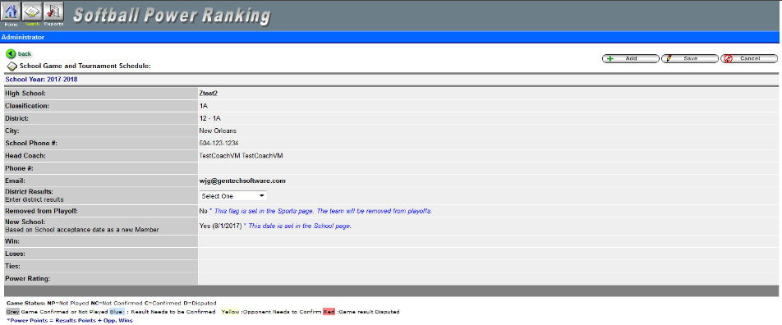

1. Enter Game Date, Opponent (from the drop-down list), and be sure to clear the check mark if the game is a district match.

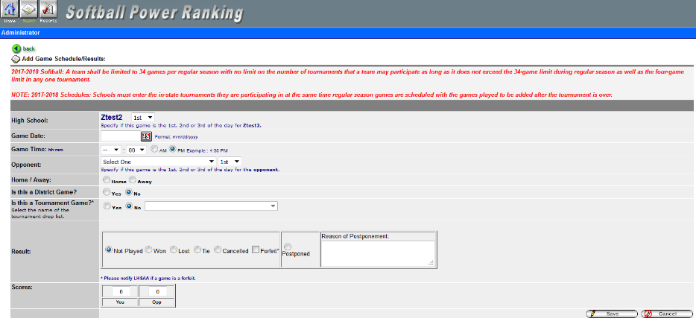

1. Click SAVE.
2. On the 1st Official contest date, all games and/or tournaments listed on online schedules shall be considered a binding contract. LHSAA Assistant Executive Director, Karen Hoyt will need email confirmation from both coaches agreeing to any/all changes, updates and/or deletions of match(s) in question.

***\*\* The Home Teams’ score books shall serve as the official documentation to resolve all score disputes and is responsible for entering the game results with the opposing coach receiving an email alert to confirm. \*\****

instructions for entering played GAMES

1. Log on to [www.lhsaaonline.org](http://www.lhsaaonline.org) using your assigned username and password
2. Click EDIT button 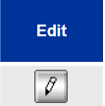 to enter the game scores and results

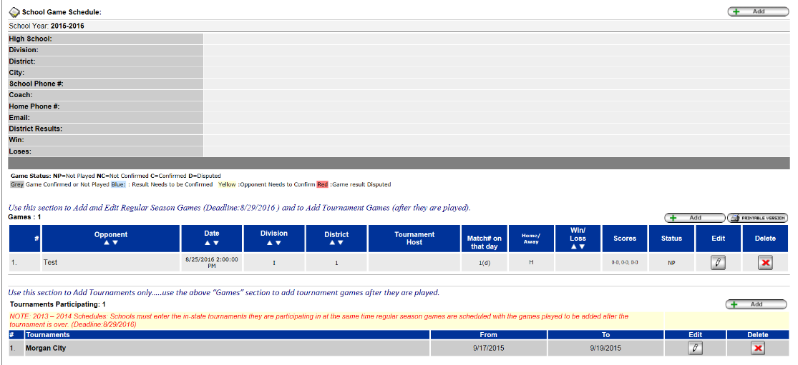

1. After the scores have been entered and saved, the system will automatically generate an email and send to the opponents’ head coach for them to confirm the scores and results. These games will be highlighted in YELLOW, which means that the opponent’s head coach needs to confirm the scores and results.

confirming a GAME

1. Log onto [www.lhsaaonline.org](http://www.lhsaaonline.org) using your username and password
2. Click EDIT. Games that need to be confirmed by this coach will show highlighted in BLUE.
3. If the score is correct then click CONFIRM AND SAVE.
4. If there is a discrepancy, click the dispute tab and enter the reason for the dispute and SAVE. The system will automatically send an email to the LHSAA Assistant Executive Director, Karen Hoyt. All disputed games will be highlighted in RED.

***\*\*At the end of the regular season, District Chairpersons shall be responsible for reporting their district champion on the official ‘LHSAA District Champion’ electronic form via the LHSAA Member website on the deadline cited in Rule 19.1 – Important Dates Section.\*\****

editing playoff brackets

1. Log onto [www.lhsaaonline.org](http://www.lhsaaonline.org) using your username and password
2. You will see 5 tabs – click on the tab that says PLAYOFF BRACKETS

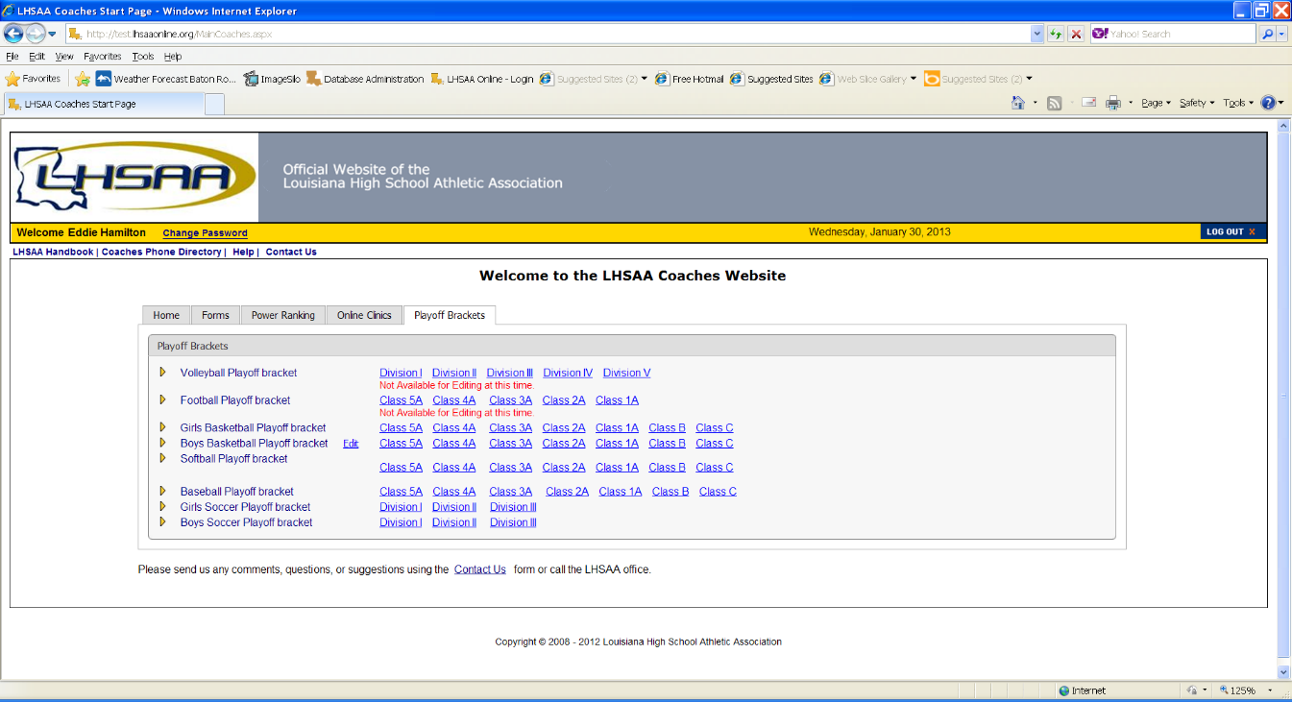

1. Click on the EDIT tab that will be located beside the

*Softball Playoff Bracket*

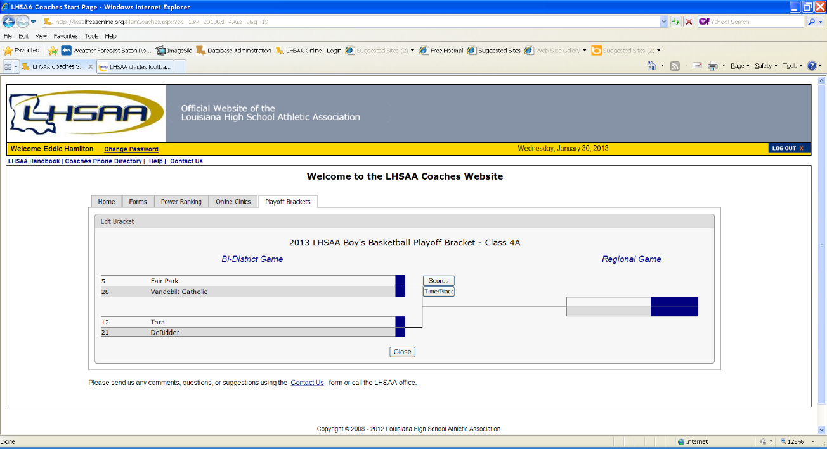

1. You will see a four-team mini bracket that will show your opponent and the two other teams in your bracket. You will see two boxes – one will say SCORES in it and the other will have TIME/PLACE.

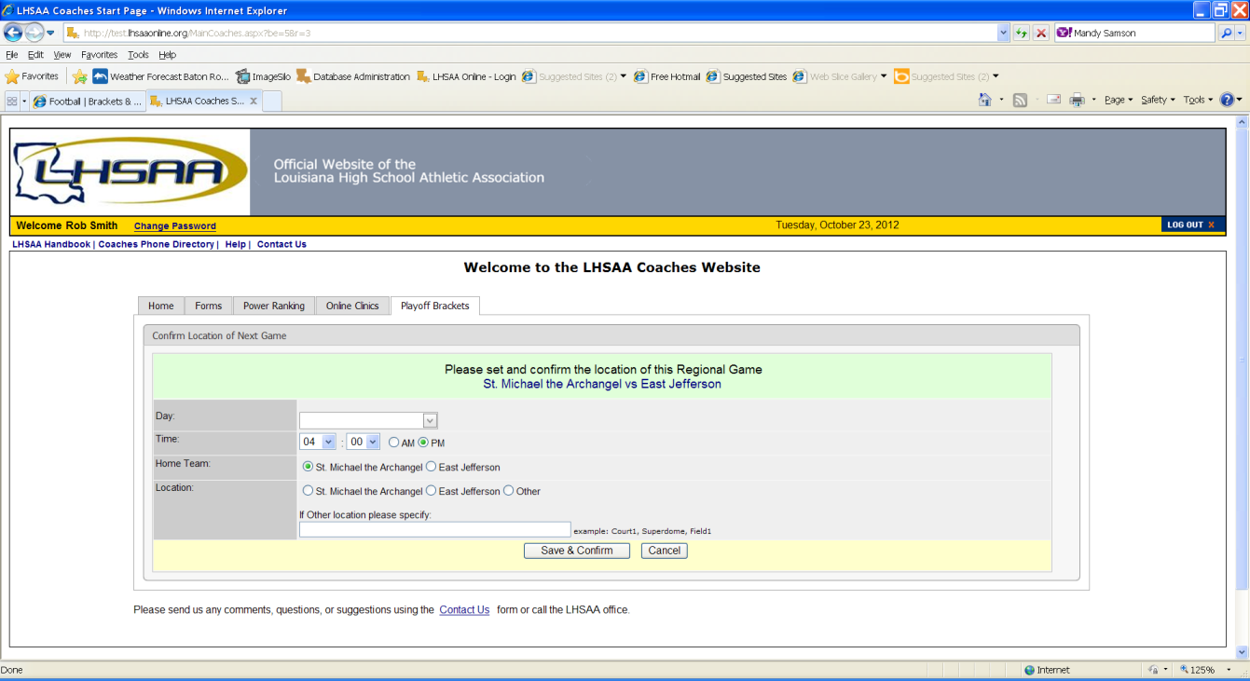

1. Click on TIME/PLACE to enter the following
2. Day of your game
3. Time of your game
4. Location of game
5. Home and Away teams
6. Once you have entered the requested information

and reviewed it for any possible errors

5. Click SAVE & CONFIRM.

entering playoff GAME results

1. The coach of the winning team will log on to the LHSAA Member site [www.lhsaaonline.org](http://www.lhsaaonline.org) *(see screen shot on previous page)*
2. You will see 5 tabs – click on the tab that saysPLAYOFF BRACKETS
3. Click on the EDIT tab that will be located beside the *Softball Playoff Brackets (see screen shot on previous page)*
4. You will see a four team mini bracket that will show your opponent and the two other teams in your bracket. You will see two boxes – one will say SCORES in it and the other will have TIME/PLACE.

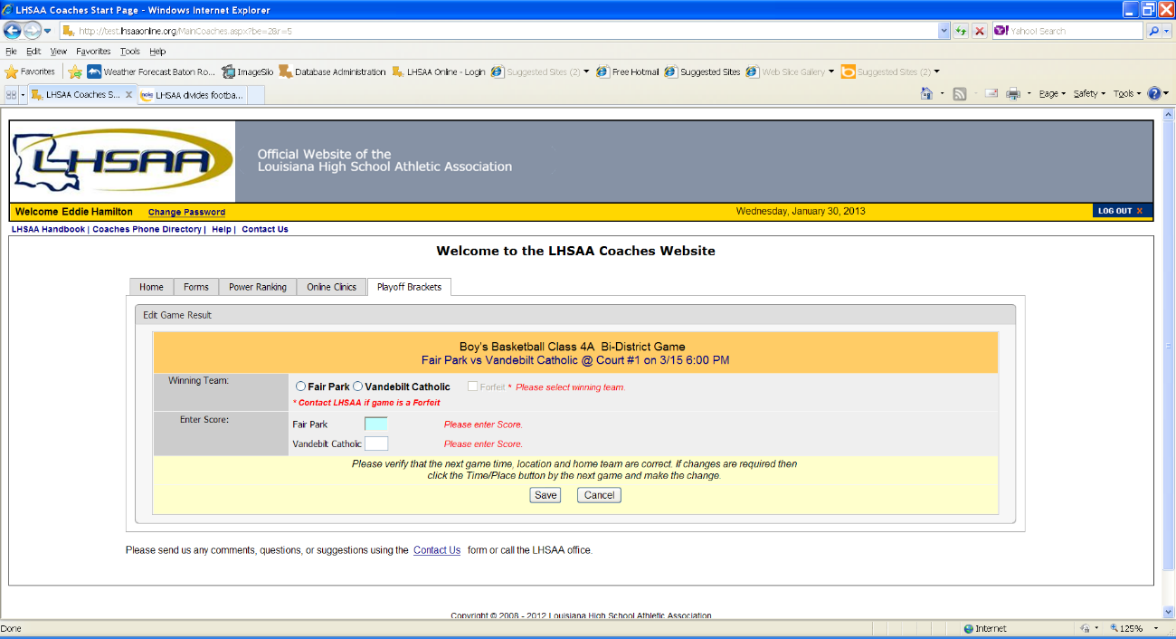

Steps to follow to enter your game results**:**

1. Click on SCORE to enter your game results
2. Click on winning team and enter the score
3. Click on losing team and enter the score
4. Once you have reviewed the information for any possible

errors

1. Click SAVE

*The winning team will automatically advance to the regional round on the bracket.

**NOTE:** The TIME/PLACEscreen will open so you can enter the Date, Time, Home Team, Location and location details of the next round. If you do not know your next opponent, please click the CANCEL button. You can enter this information once you know who your next opponent will be.

*Please keep this document and if you have any questions, please contact LHSAA Assistant Executive Director, Karen Hoyt (*[*khoyt@lhsaa.org*](mailto:khoyt@lhsaa.org)*) or her Administrative Assistant, S. Lacy Macdiarmid (lmacdiarmid@lhsaa.org).*