***2024-25***

***Volleyball General***

***Information Bulletin***

table of contents

|  |  |
| --- | --- |
| **CONTENT** | ***PAGE(S)*** |
| general information | Pages 1-2 |
| district scheduling meeting/2024-2025 lhsaa sponsors | Page 3 |
| instructions for head coach taking mandatory online rules clinic | Page 4 |
| instructions for entering volleyball SCHEDULES ON lhsaa member site | Pages 5-6 |
| instructions for entering played matches | Page 7 |
| confirming a match | Page 8 |
| editing playoff brackets | Page 9 |
| entering playoff match results | Page 10 |

2024-25 volleyball general information

*This Bulletin is for your benefit. Please read and make sure all necessary parties receive the correct information concerning the event.*

|  |  |
| --- | --- |
| **CATEGORY** | **DATE/INFORMATION** |
| LHSAA Volleyball Rules | Completely familiarize yourself with Section 24 as well as all necessary sections of the 2024-2025 Handbook. The Handbook and can be found on www.lhsaa.org. |
| Adding Tournaments &  Jamborees Online | Tournament & Jamboree [Instructions](https://www.lhsaa.org/siteuploads/editorimg/file/Volleyball/Instructions%20on%20adding%20Jamborees%20and%20Tournaments%20online.pdf) |
| 1st Practice/Earliest Scrimmage | Monday, August 12, 2024 |
| Jamboree Dates | Monday, August 26 – Saturday, August 31, 2024   1. Jamborees must have a minimum of 3 teams and 2 games. 2. Host schools must submit approval forms and fees by Monday, August 12, 2024. 3. Fees are $50 for each jamboree. (***By-law 6.10.8***) 4. All jamborees shall be approved, or the host school will be penalized.   No other financial reports or additional monies are required by the LHSAA. |
| Deadline for Submitting Working Schedules Online | Saturday, August 31, 2024 - Deadline to submit online version of your school’s varsity schedule on the LHSAA Member’s Only website. Failure to do so shall result in the school being fined $100. (***By-law 6.12.1***) |
| 1st Contest (If Jamboree Not Played) | Monday, September 2, 2024 |
| Reporting Weekly Match Results | Beginning with the first playing date of the season, the home team principal, or his/her designee, shall be required to enter the volleyball match results, including tournament games, online no later than 11:59 p.m. on the date the contest is played. Unless disputed by 10:00 p.m. on each Monday of each week, the results will stand as posted. Failure by the home team to submit game results shall result in the home team  being fined $50 for each weekly report not submitted to the LHSAA by the established deadline. (***By-law 6.12.2)*** |

*2024-25 Volleyball General Information Bulletin | 1*

2024-25 volleyball general information

*continued*

|  |  |  |  |
| --- | --- | --- | --- |
| **CATEGORY** | | **DATE/INFORMATION** | |
| Reporting Playoff Match Results | | A school representative from the home team is responsible for reporting the score online immediately after each playoff contest so that the next playoff contest can be arranged. In all team sports, if the home team fails to report the outcome of a state playoff contest to the LHSAA by 11:00 p.m. on the day of the contest, the school shall be fined $100.  (***By-law 6.13.8)*** | |
| All-Academic Submission Deadline | | Monday, October 7, 2024 | |
| Last Date to Add a Match to Schedule for Power Rating Purposes | | Saturday, October 26, 2024 | |
| End of Regular Season/  District Representatives Named | | Saturday, November 2, 2024 - The district chairperson shall report the name of the 1st place representatives in their district on the official LHSAA District Final Standing Form to the LHSAA Assistant Executive Director, Karen Hoyt by 10:00 p.m. | |
| Playoff Pairings Named  @ Dispute Period | | Monday, November 4, 2024 **(Bylaw 6.12.6 & 24.1)** | |
| Playoff Competition | | Please refer to the ‘Athletic Contest’ and ‘Volleyball’ sections of the LHSAA Handbook. | |
| Playoff Dates  Wednesday, November 6, 2024  Thursday, November 7, 2024  Friday, November 8, 2024  Saturday, November 9, 2024 | Round  Bi-District  Bi-District  Regional  Regional | | Divisions  Divisions III, IV, and V  Divisions I and II  Division III, VI, and V  Divisions I and II |
| LHSAA State Volleyball Tournament  Thursday, November 14, 2024 – Saturday, November 16, 2024  Cajundome, Lafayette, LA | | | |

*2024-25 Volleyball General Information Bulletin | 2*

district scheduling meeting

* The District Chairperson shall notify all district members at least ten (10) days in advance of the date, time and place of meeting.
* Member schools shall declare in writing, at the meeting, if they will play a varsity schedule and/or if they will play for district honors.
* The District Chairperson and the school’s principal shall notify the LHSAA in writing of the school(s) that will not play for district honors and/or varsity schedules.
* The district principals shall approve the schedule.
* The chairperson shall take and keep the minutes of the meeting.

2024-2025 LHSAA SPONSORS

* The 2024-2024 LHSAA Sponsor page can be found here.

*2024-25 Volleyball General Information Bulletin | 3*

instructions for head coach

taking mandatory online rules clinic

1. Log on to www.lhsaaonline.org

2. The head Volleyball coach should receive a username and password from his/her principal that will be used throughout the Volleyball season. If you do not have one or forgot your username and/or password, please contact your school principal.

3. Click the Online Rules Clinic Tab

4. Listed under Sports Clinics will be the link to complete the Volleyball Online Rules Clinic when it becomes available. (See dates listed above)

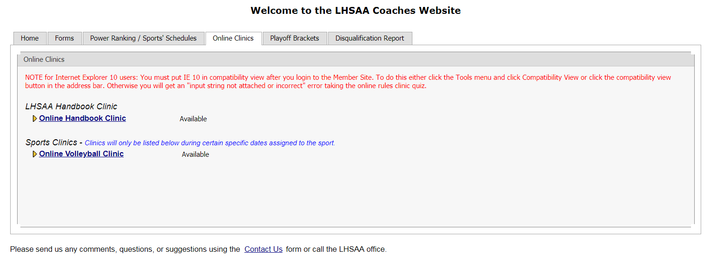

*2024-25 Volleyball General Information Bulletin | 4*

instructions for entering volleyball schedules into the lhsaa member site

*Do not enter jamborees, junior varsity and Hall of Fame matches as these matches do not receive power points.*

1. Log on to www.lhsaaonline.org using your assigned username and password
2. Click the Power Ranking Tab
3. Click Volleyball Power Ranking
4. To add games to your schedule click the ADD button at the top right of the screen
5. 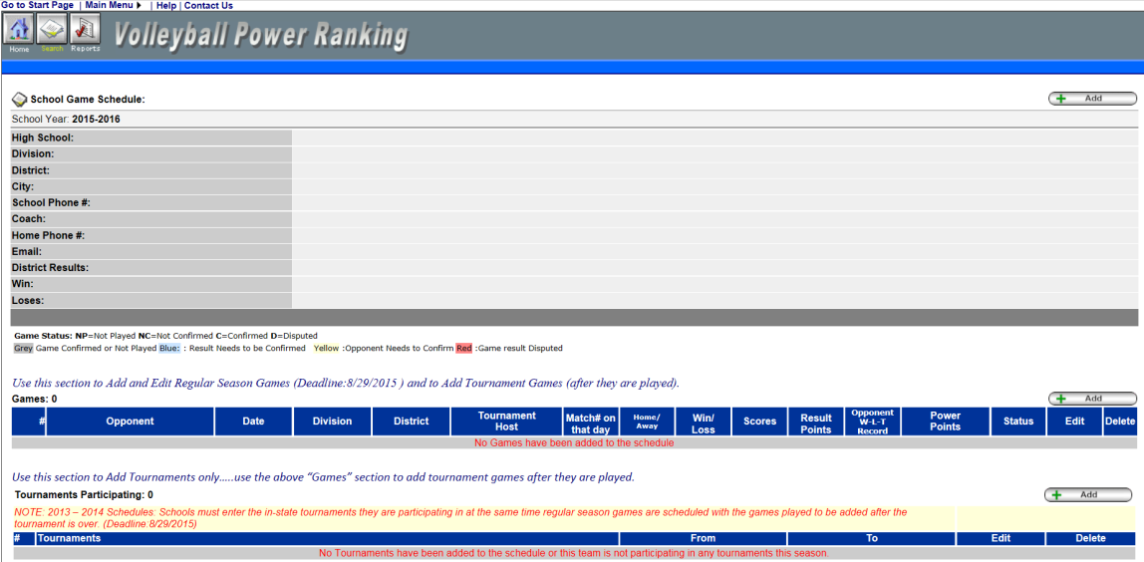To add Tournaments, click ADD at the bottom right of the screen. (Only add tournaments, add the tournament matches after they are played in the matches section.)
6. 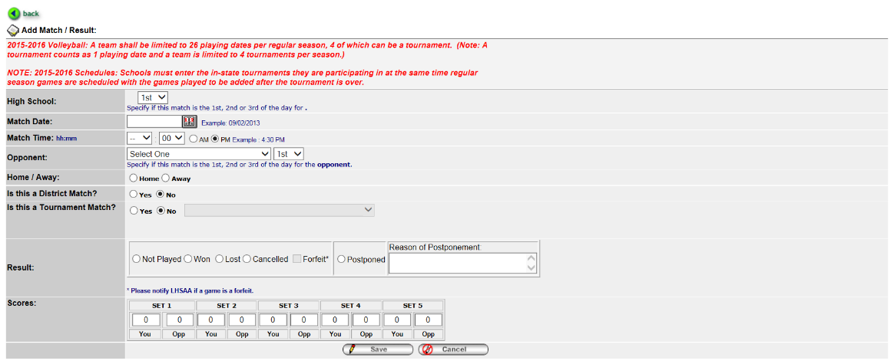Enter Match Date, Opponent (from the drop down list), and be sure to clear the check mark if the match is a district match.

*2024-25 Volleyball General Information Bulletin | 5*

instructions for entering volleyball schedulesinto the lhsaa member site continued

1. Click SAVE.
2. Once a match is entered and needs to be deleted prior to the 1st Official playing date, email LHSAA Assistant Executive Director, Karen Hoyt @ [khoyt@lhsaa.org](mailto:khoyt@lhsaa.org).
3. On the 1st official contest date, all matches and/or tournaments listed on online schedules shall be considered a binding contract. LHSAA Assistant Executive Director, Karen Hoyt will need email confirmation from ***both*** coaches agreeing to any/all changes, updates and/or deletions of match(s) in question.

***\*\* The Home Teams’ score books shall serve as the official documentation to resolve all score disputes and is responsible for entering the match results with the opposing coach receiving an email alert to confirm.\*\****

*2024-25 Volleyball General Information Bulletin | 6*

instructions for entering played matches

1. Log on to www.lhsaaonline.org using your assigned username and password.
2. 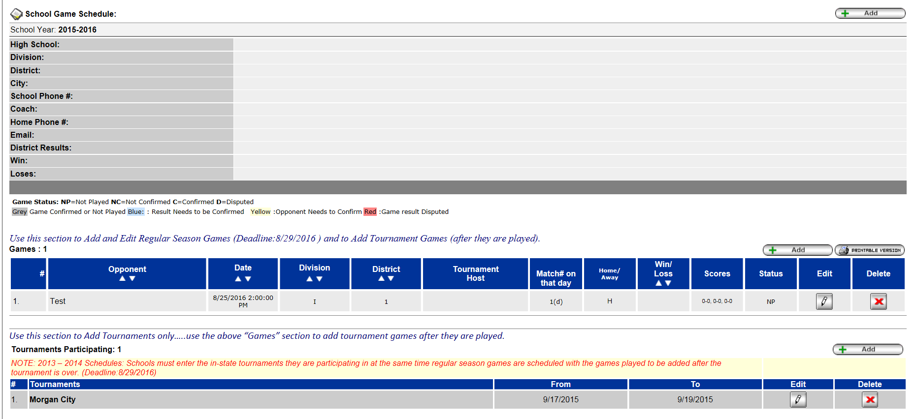Click EDIT button 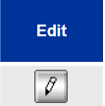 to enter the match scores and results.
3. After the scores have been entered and saved, the system will automatically generate an email and send it to the opponents’ head coach for them to confirm the scores and results. These matches will be highlighted in YELLOW, which means that the opponent’s head coach needs to confirm the scores and results.

*2024-25 Volleyball General Information Bulletin | 7*

confirming a match

1. Log onto www.lhsaaonline.org using your username and password.
2. Click EDIT. Matches that need to be confirmed by this coach will show highlighted in BLUE.
3. If the score is correct then click CONFIRM AND SAVE.
4. If there is a discrepancy, then click the dispute tab and enter the reason for the dispute and SAVE. The system will automatically send an email to the LHSAA Assistant Executive Director, Karen Hoyt. All disputed matches will be highlighted in RED.

***\*\*At the end of the regular season, District Chairpersons shall be responsible for reporting their district champion on the official ‘LHSAA District Champion’ electronic form via the LHSAA Member website on the deadline cited in Rule 24.1 – Important Dates Section.***

*2024-25 Volleyball General Information Bulletin | 8*

editing playoff brackets

1. Log onto www.lhsaaonline.org using your username and password.
2. You will see 5 tabs – click on the tab that says PLAYOFF BRACKETS

1. Click on the EDIT tab that will be located beside the *Volleyball Playoff Bracket.*

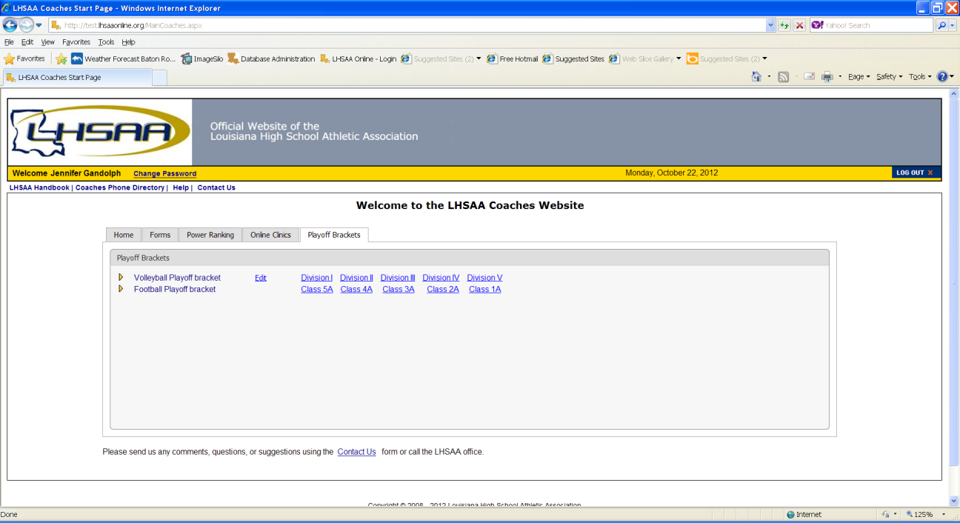

1. You will see a four-team mini bracket that will show your opponent and the two other teams in your bracket. You will see two boxes – one will say SCORES in it and the other will have TIME/PLACE.

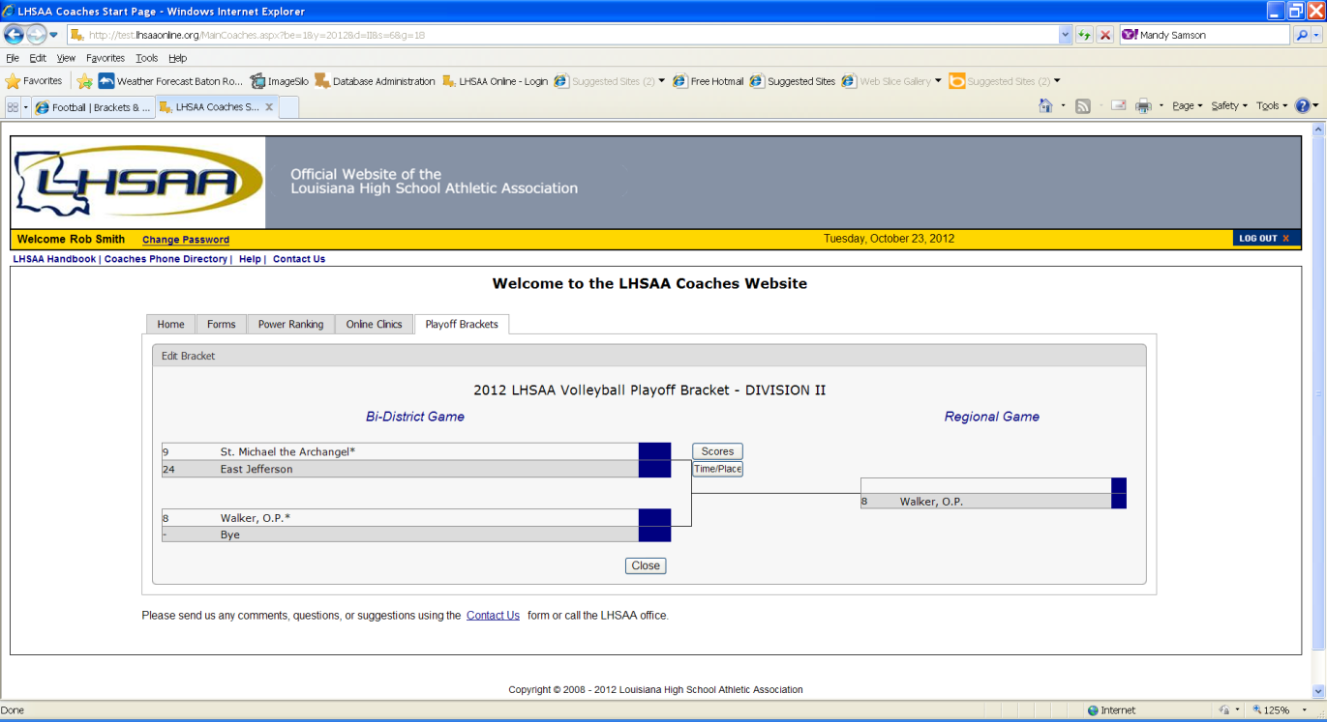

1. Click on TIME/PLACE to enter the following:
2. Day of your match
3. Time of your match
4. Location of match
5. Home and Away teams

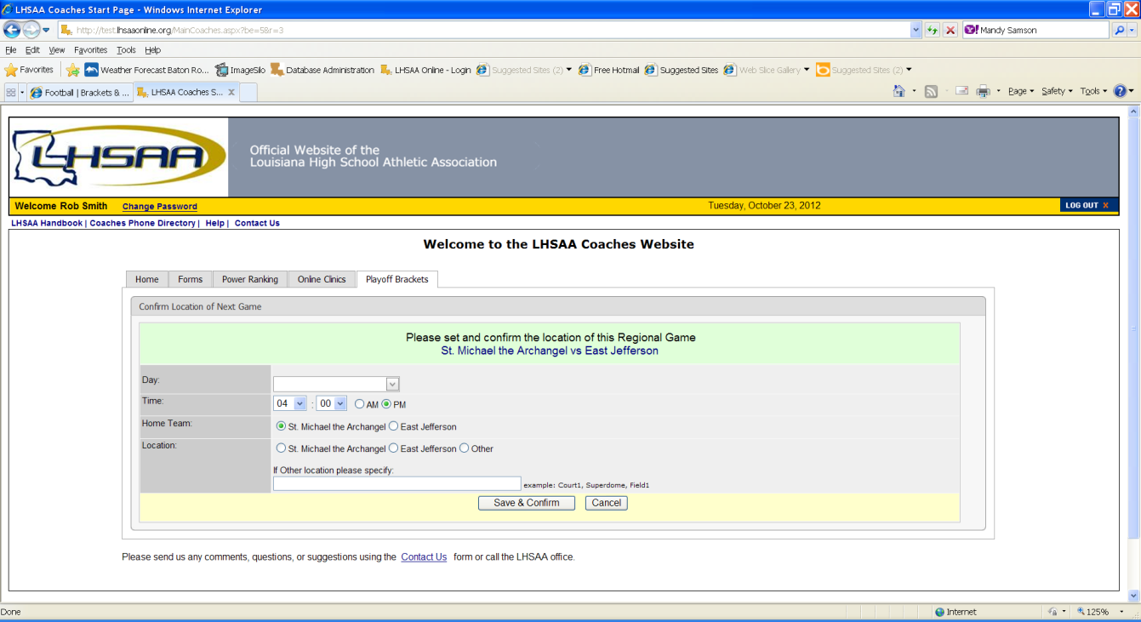

5. Once you have entered the requested information and reviewed

it for any possible errors, click SAVE & CONFIRM.

*2024-25 Volleyball General Information Bulletin | 9*

entering playoff match results

1. The coach of the winning team will log on to the LHSAA Member site www.lhsaaonline.org *(see screen shot on previous page)*
2. You will see 5 tabs – click on the tab that saysPLAYOFF BRACKETS.
3. Click on the EDIT tab that will be located beside the *Volleyball Playoff Brackets. (see screen shot on previous page)*
4. 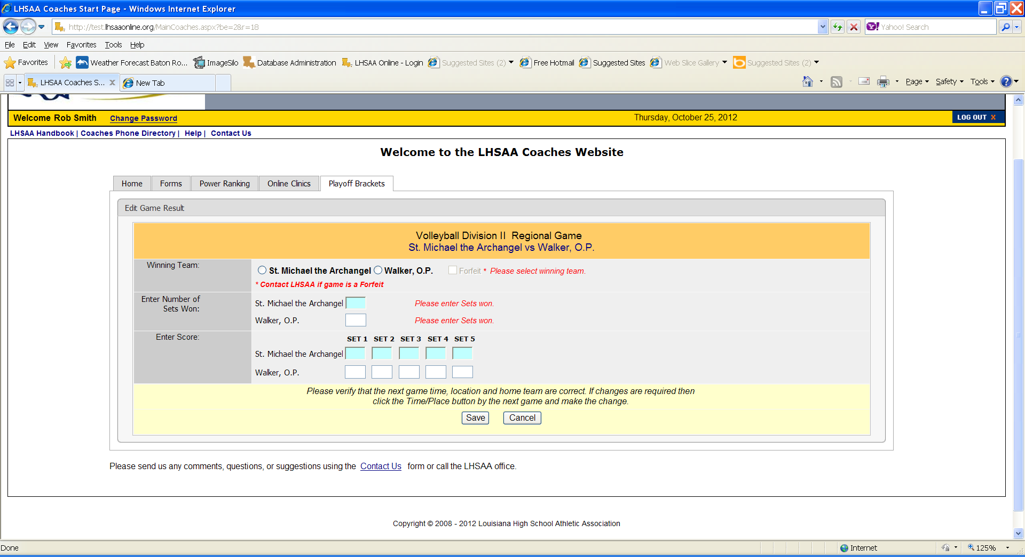You will see a four team mini bracket that will show your opponent and the two other teams in your bracket. You will see two boxes – one will say SCORES in it and the other will have TIME/PLACE.

Steps to follow to enter your match results**:**

1. Click on SCORE to enter your match results
2. Click on winning team
3. Enter the number if sets won by the winning team
4. Enter the number if sets won by the losing team
5. Once you have reviewed the information for any possible errors
6. Click SAVE. The winning team will automatically advance to the regional round on the bracket.

**NOTE:** The TIME/PLACEscreen will open so you can enter the Date, Time, Home Team, Location and location details of the next round. If you do not know your next opponent, please click the CANCEL button. You can enter this information once you know who your next opponent will be.

*Please keep this document and if you have any questions, please contact LHSAA Assistant Executive Director, Karen Hoyt (**khoyt@lhsaa.org**) or her Administrative Assistant, S. Lacy Macdiarmid (lmacdiarmid@lhsaa.org).*

*2024-25 Volleyball General Information Bulletin | 10*