**Louisiana High School Athletics Association**

Concussion Information and Resources for Coaches, Officials, Student-Athletes and Parents

**Introduction**

Concussions are one of the most reported injuries in children and adolescents who participate in sports and recreational activities. The Centers for Disease Control and Prevention (CDC) estimate that as many as three million nine hundred thousand sports-related and recreation-related concussions occur in the United States each year. A concussion is caused by a blow or motion to the head or body that causes the brain to move rapidly inside the skull. The risk for long-term, chronic cognitive, physical, and emotional symptoms is significant when a concussion or head injury is not properly recognized, evaluated, and managed. Continuing to play with a concussion or symptoms of head injury leaves the young athlete especially vulnerable to greater catastrophic injury and even death. Although research is constantly expanding and ever evolving around the connection between sport related concussion injuries and conditions such as post-concussion syndrome and chronic traumatic encephalopathy, basic knowledge of concussion injuries as well as adoption of proper recognition and evidence-based management techniques remain paramount to protect the youth athlete.

The Legislature of Louisiana recognized the need to establish a law to protect our athletes and provide guidelines on concussion management leading to the signing and enacting of the "Louisiana Youth Concussion Act" in 2011.

The Louisiana High School Athletics Association (LHSAA) Sports Medicine Advisory Committee serves as an advocate for the health and safety for all LHSAA student-athletes and is a trusted advisor for the LHSAA to create guidelines and recommendations to assist with proper risk reduction, recognition, and management of these sport related injuries.  This committee has met and developed guidance and resources to help LHSAA member schools comply with state law. This document includes sample educational materials and resources to disseminate to coaches, officials, student-athletes, and their parents to help LHSAA members be compliant with their responsibilities detailed in the law. This documentation should be exclusively kept on file at the school as the LHSAA does not require a copy of these documents.

Here's to a safe and successful season for all participating schools, teams, athletes, and officials.

Respectfully,

Eddie Bonine

LHSAA Executive Director

**ACT 314: Louisiana Youth Concussion ACT**

ACT 314 gives the responsibility of compliance of the act to the governing authority of each public and nonpublic elementary school, middle school, junior high school, and high school. It has three major requirements.

1. Prior to beginning of each athletic season, provide pertinent information to all coaches, officials, volunteers, youth athletes, and their parents or legal guardian which informs of the nature and risk of concussion and head injury, including the risks associated with continuing to play after a concussion or head injury.
2. Require each coach, whether such coach is employed or a volunteer, and every official of a youth activity that involves interscholastic play to compete an annual concussion recognition education course.
3. Requires as a condition of participation in any athletic activities that the youth athlete and the youth athlete's parent or legal guardian sigh a concussion and head injury information sheet which provides adequate notice of the statutory requirements which must be satisfied in order for an athlete who has or is suspected to have suffered a concussion or head injury to return to play.

Educational Materials and Resources

* LHSAA Concussion Rule (Adopted in 2010)
* Condensed SCAT 6
* Return to Learn Progression (Sample)
* Return to Play Progression (Sample)
* LHSAA Return-to-Competition Form
* Center for Disease Control and Prevention (CDC) Heads Up Fact Sheet for
  + High School Coaches
  + Officials
  + Student-Athletes, and Parents
* LHSAA Concussion Statements for
  + Coaches
  + Officials
  + Student-Athletes and Parents

To help meet the education course aspect of ACT 314, the LHSAA recommends that individuals go to the NFHS website, [www.nfhslearn.com,](http://www.nfhslearn.com/) and click the link Concussion in Sports, under Courses.

Additional Resources:

Louisiana ACT No. 314

<https://lern.la.gov/wp-content/uploads/Act_314_-_2011_Reg_Session.pdf>

National Federation of State High School Associations (NFHSA) Suggested Guidelines for Management of Concussion in Sports

<https://www.nfhs.org/media/1020401/suggested-guidelines-for-management-of-concussion-in-sports-april-2019-final.pdf>

Sport Concussion Assessment Tool 6 (SCAT6)

<https://bjsm.bmj.com/content/57/11/622>

Centers for Disease Control and Prevention (CDC Heads Up Resources)

<https://www.cdc.gov/headsup/index.html>

**LHSAA BASIC CONCUSSION RULE**

Any player who exhibits signs, symptoms, or behaviors consistent with a concussion (such as Ioss of consciousness, headache, dizziness, confusion or balance problems) shall be immediately removed from the contest and shall not return to play until cleared by an appropriate health care professional.

*A concussion is a traumatic brain injury that interferes with normal brain function. An athlete does not have to lose consciousness to have suffered a concussion.*

Concussion symptoms include:

* Headache
* "Pressure in head"
* Neck pain
* Nausea or vomiting
* Dizziness
* Blurred vision
* Balance problems
* Sensitivity to light
* Sensitivity to noise
* Feeling slowed down
* Feeling "in a fog"
* "Don't feel right"
* Difficulty concentrating
* Difficulty remembering
* Fatigue or low energy
* Confusion
* Drowsiness
* Trouble falling asleep
* More emotional
* Irritability
* Sadness
* Nervous or anxious

LHSAA Adopted Concussion Management Protocol:

1. No athlete shall return to play (RTP) or practice on the same day of a concussion.
2. Any athlete suspected of having a concussion shall be evaluated by a health-care professional, when clinically appropriate.
   1. Health care provider definition: “Health care provider” means a physician as defined in R.S.37:1262(2), a licensed nurse practitioner, or licensed physician assistant.
3. Any athlete diagnosed with concussion shall be medically cleared by a health care provider, each of which must be licensed to practice in Louisiana, prior to resuming participation in any practice or competition.
4. After medical clearance, RTP should follow a step-wise protocol with provisions as determined by the health care provider, each licensed to practice in Louisiana, for delayed RTP based upon return of any signs or symptoms.

**Condesed SCAT 6**

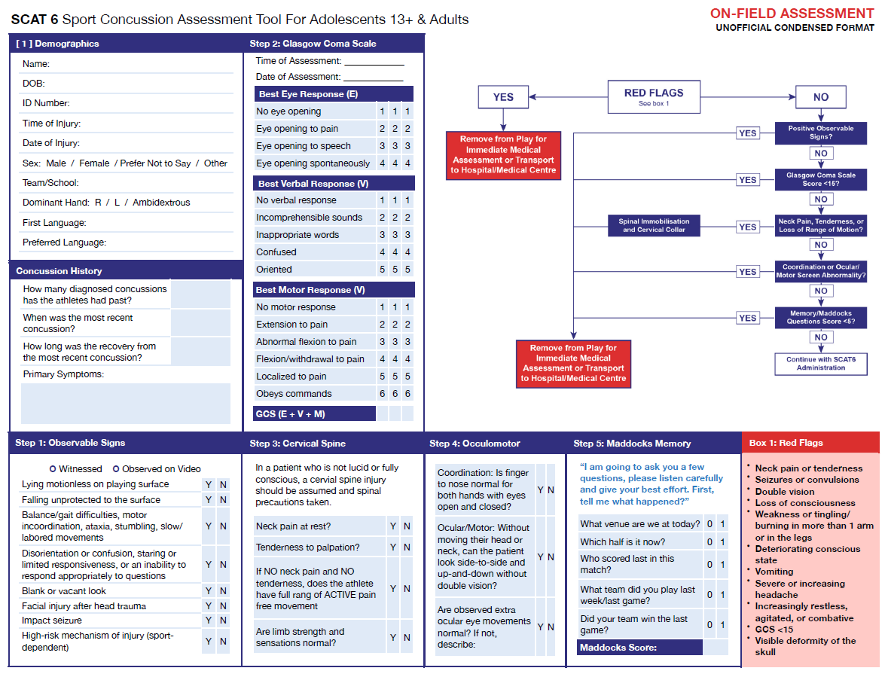

Sport Concussion Assessment Tool 6 (SCAT6)

<https://bjsm.bmj.com/content/57/11/622>

**Return To Learn Protocol**

1. Prepare to return to academic activities
   1. Begin light mental activity for short periods of time (about 15 minutes several times/day)
   2. Limit other mental/cognitive activities, especially those that worsen symptoms
      1. For example, computers, phones, video games
2. Begin light activity academics
   1. Return to class
      1. This may be a single class or limited number of classes at first
      2. See if a classmate can take notes while you work on paying attention
      3. Change seating arrangement to limit distractions/stimulation
   2. Work on short/small assignments
      1. Work for short periods with rest in between
      2. Avoid computer, if able, due to the risk of eye strain, headache, or neck tension
   3. Continue to limit problematic cognitive activities
      1. Computer, texting, watching TV, etc.
3. Increase academic workload
   1. Return to more/all classes
      1. Begin taking notes
      2. Work on major assignments, tests, and projects
4. Return to normal academic workload
   1. Return to ALL classes
   2. Arrange to take tests and complete missed work, if any

*The Return to Learn Progression can begin at any stage depending on the student athlete’s symptoms. The health care provider will make that determination.

***Progression through the strategy is symptom limited (i.e., no more than a mild and brief exacerbation of current symptoms related to the current concussion) and its course may vary across individuals based on tolerance and symptom resolution. Further, while the Return to Learn (RTL) and Return to Sport (RTS) strategies can occur in parallel, student athletes should complete full RTL before unrestricted RTS.***

**Return To Play Protocol**

|  |  |  |
| --- | --- | --- |
| Rehabilitation Stage | Functional Exercise at Each Stage of Rehabilitation | Objective of Each Stage |
| 1. No Activity | Symptom limited physical and cognitive rest | Recovery |
| 2. Light aerobic exercise | Walking, swimming, or stationary cycling keeping intensity <70% maximum permitted heart rate | Increase heart rate Perform for 30 minutes |
| 3. Sport-specific exercise | Skating drills in hockey. Running drills in soccer. No head impact activities. | Add movement Perform for 30 minutes |
| 4. Non-contact training drills | Progression to more complex training drills. For example, passing drills in football and soccer | Improve exercise, coordination, and increase cognitive load |
| 5. Full contact practice | Following medical clearance participate in normal training activities | Restore confidence and assess functional skills by coaching staff |
| 6. Return to play Normal game play | Normal game play |  |

**If at any point concussion symptoms present or worsen, the player is to stop athletic activity. The health care provider will determine if the player must return to the prior step or re-attempt the stage on the following day. Once the prior step is completed without symptoms, the player may progress to the next step and attempt to complete it again.**

***Progression through the strategy is symptom limited (i.e., no more than a mild and brief exacerbation of current symptoms related to the current concussion) and its course may vary across individuals based on tolerance and symptom resolution. Further, while the Return to Learn (RTL) and Return to Sport (RTS) strategies can occur in parallel, student athletes should complete full RTL before unrestricted RTS.***

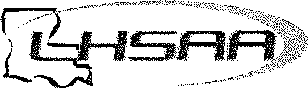

**LHSAA Return to Competition Form**

The LHSAA requires a written statement from a health care provider for an athlete to return to competition after sustaining a concussion or head injury.

"If a competitor is determined to have a concussion, he/she shall not be permitted to continue practice or competition the same day. Written approval of a heath care provider shall be required for the athlete to return to competition. If a health care provider recommends an athlete not continue, he/she shall not be overruled."

The undersigned attending health care provider has examined the student-athlete identified below and gives permission for the student-athlete to return to competition on the date and in the sport identified.

*"Health care provider” means a physician as defined in R.S.37:1262(2), a licensed nurse practitioner, or licensed physician assistant.*

|  |  |
| --- | --- |
| **Athlete** | **Sport** |
| **School** | |
| **Date of Concussion** | **Date to Return** |
| **Attending Health Care Provider** | **LA Medical License** |

**Attending Health Care Provider Signature: _____________________________________________________**

**Date: ____________________________**

Athletes must receive written clearance from their health care provider to complete the graduated return to play progression.

*This form shall be completed in its entirety and should be maintained by the school and the health care professional. The LHSAA does not maintain this record.*

**CDC Heads Up Fact Sheet for High School Coaches**

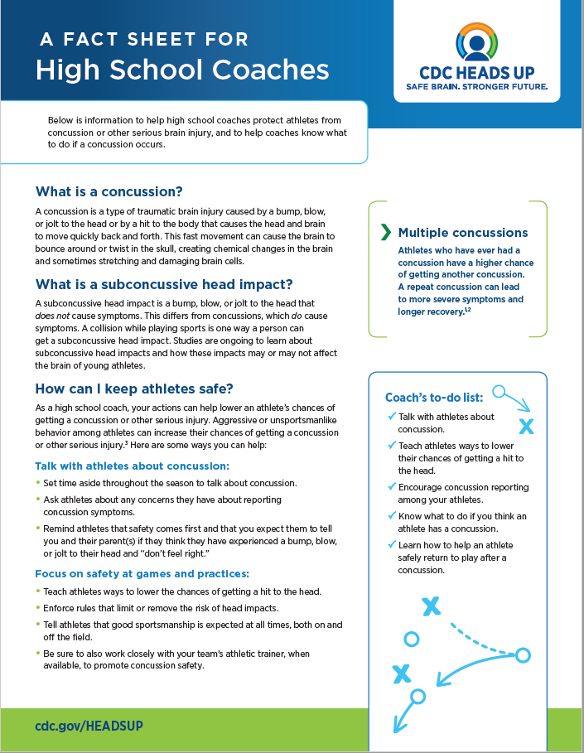

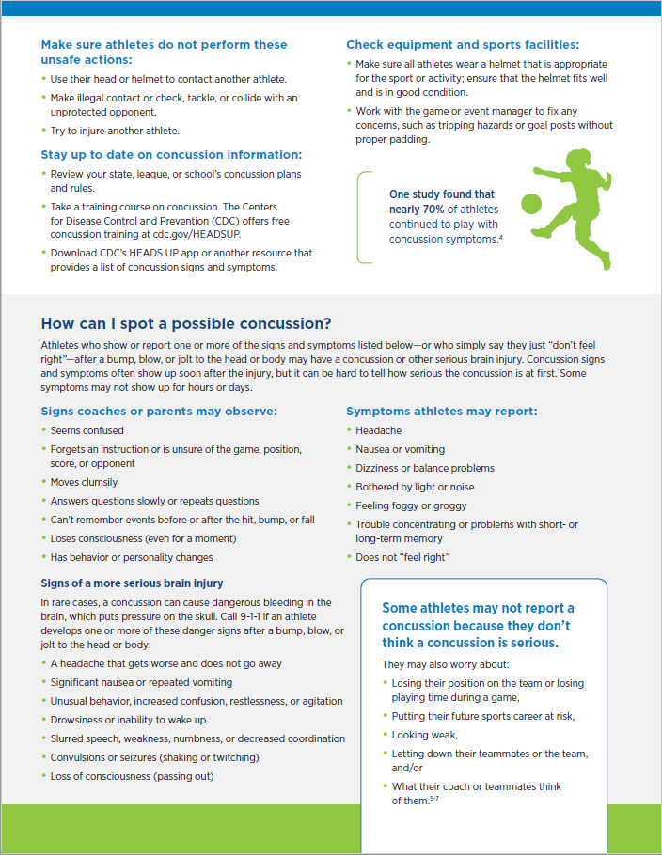

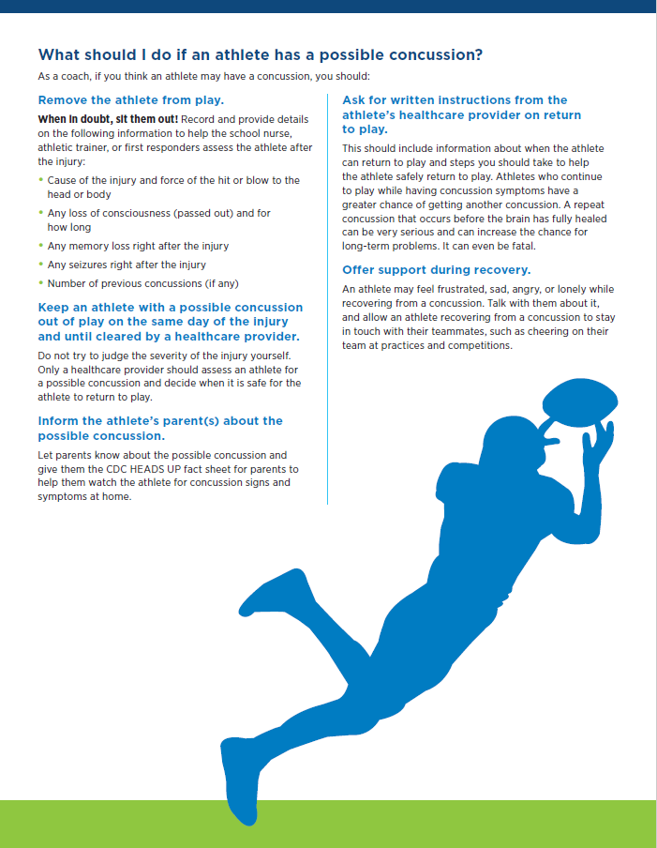

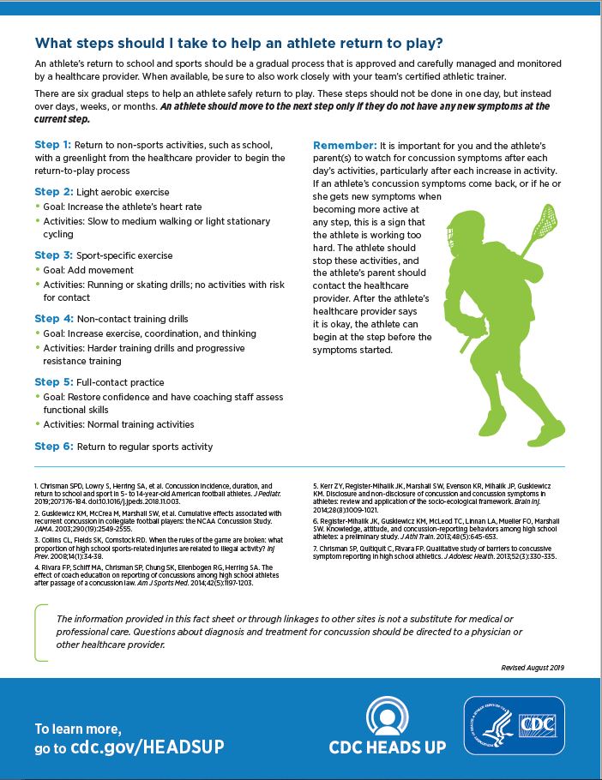

**Louisiana High School Athletic Association**

**Coaches Concussion Statement**

After reading the CDC Heads Up Concussion Fact Sheets and reviewing the LHSAA Concussion Management Protocol, I am aware of the following information:

|  |  |
| --- | --- |
| Initial: |  |
|  | A concussion is a brain injury which athletes should report to their health care provider or athletic trainer. |
|  | A concussion can affect the athlete’s ability to perform everyday activities, and affect reaction time, balance, sleep, and classroom performance. You cannot always see a concussion, but you might notice some of the symptoms right away. Other symptoms can show up hours or days after the injury. |
|  | Athletes shall not return to play in a game or practice on the same day that they are suspected of having a concussion. |
|  | Athletes diagnosed with a concussion must be assessed by a health care provider. Athletes will begin a graduated return to play protocol following full recovery of neurocognition and balance. |
|  | Concussed athletes are much more likely to experience complications if they return to play before symptoms resolve including but not limited to permanent brain damage or even death. |

I commit to the following:

|  |  |  |
| --- | --- | --- |
| Initial: |  | |
|  | I will not knowingly allow the athlete to return to play in a game or practice if he/she has received a blow to the head or body that results in concussion-related symptoms. | |
|  | If I suspect one my athletes has a concussion, it is my responsibility to have that athlete see the medical staff. | |
|  | I will encourage my athletes to report any suspected injuries and illnesses to the health care provider or athletic trainer, including signs and symptoms of concussions. | |
|  |
| Signature of Coach |
|  |
| Printed Name of Coach |
|  |
| Date |

This form must be kept on record with the school.

**CDC Heads Up Fact Sheet for Officials**

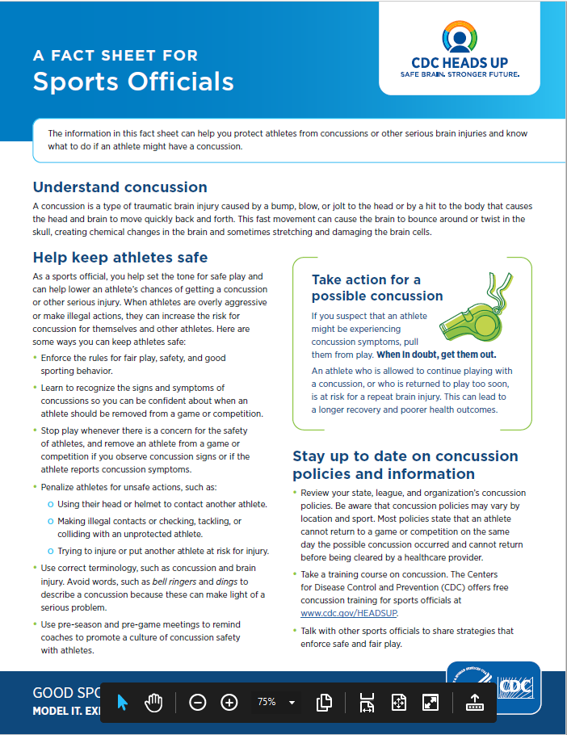

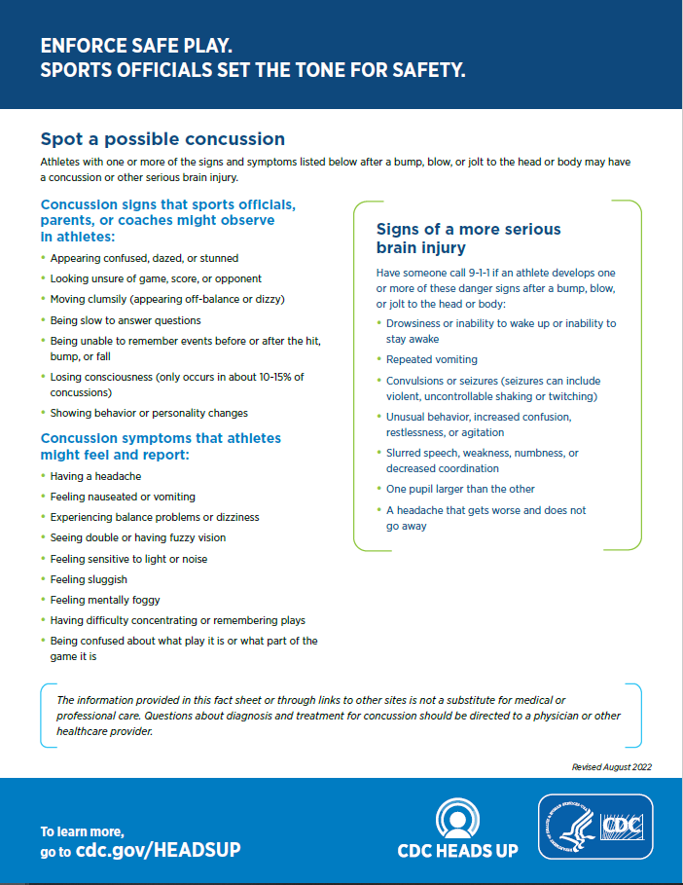

**Louisiana High School Athletic Association**

**Officials Concussion Statement**

After reading the CDC Heads Up Concussion Fact Sheets and reviewing the LHSAA Concussion Management Protocol, I am aware of the following information:

|  |  |
| --- | --- |
| Initial: |  |
|  | A concussion is a brain injury which athletes should report to their health care provider, athletic trainer, or coach. |
|  | A concussion can affect the athlete’s ability to perform everyday activities, and affect reaction time, balance, sleep, and classroom performance. You cannot always see a concussion, but you might notice some of the symptoms right away. Other symptoms can show up hours or days after the injury. |
|  | Athletes shall not return to play in a game or practice on the same day that they are suspected of having a concussion. |
|  | Athletes diagnosed with a concussion must be assessed by a health care provider. Athletes will begin a graduated return to play protocol following full recovery of neurocognition and balance. |
|  | Concussed athletes are much more likely to experience complications if they return to play before symptoms resolve including but not limited to permanent brain damage or even death. |

I commit to the following:

|  |  |
| --- | --- |
| Initial: |  |
|  | I will not knowingly allow the athlete to return to play in a game or practice if he/she has received a blow to the head or body that results in concussion-related symptoms. |
|  | If I suspect an athlete has a concussion, it is my responsibility to have that athlete see the health care provider, athletic trainer, or coach. |
|  | I will encourage my athletes to report any suspected injuries and illnesses to the medical staff, including signs and symptoms of concussions. |

|  |
| --- |
|  |
| Signature of Official |
|  |
| Printed Name of Official |
|  |
| Date |

This form must be kept on record with the Regional Coordinator of Officials for the local officials association.

**CDC Heads Up Fact Sheet for Student-Athletes**

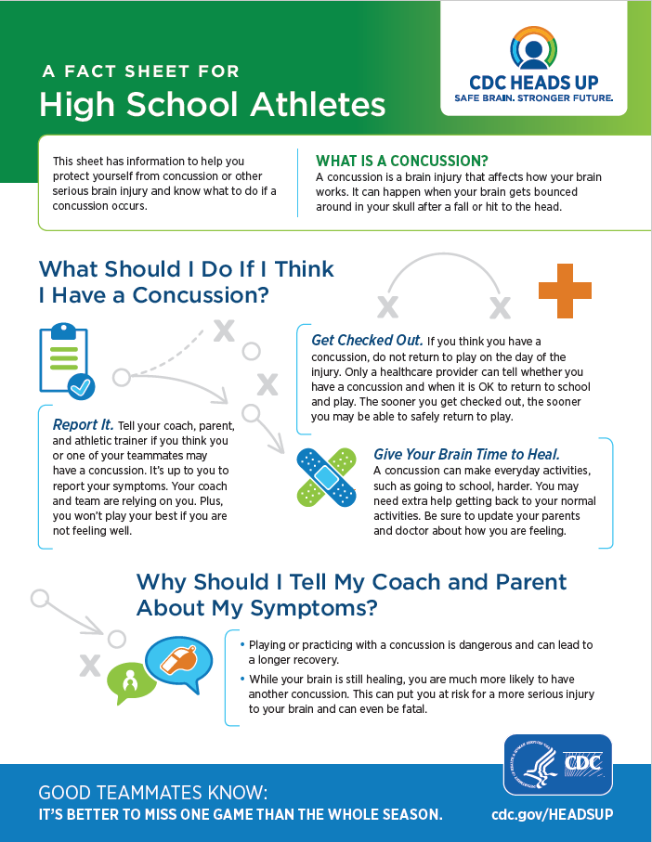

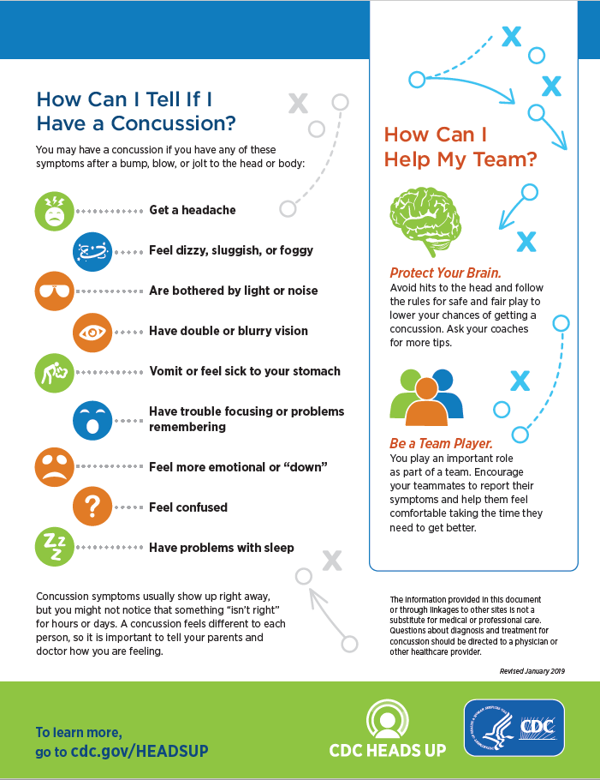

**CDC Heads Up Fact Sheet for Parents**

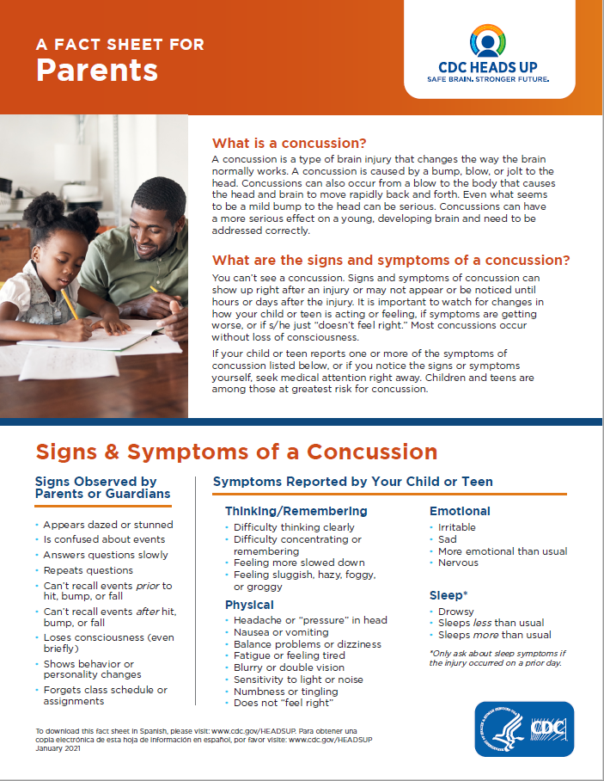

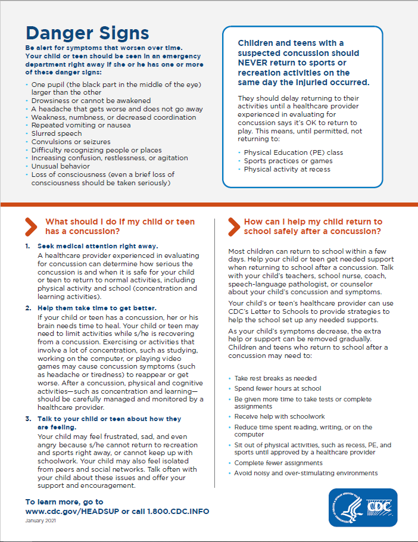

**Louisiana High School Athletic Association**

**Student-Athlete and Parent Concussion Statement**

After reading the CDC Heads Up Concussion Fact Sheets and reviewing the LHSAA Concussion Management Protocol, I am aware of the following information:

|  |  |  |  |
| --- | --- | --- | --- |
| Athlete  Initial: |  | Parent  Initial: |  |
|  |  |  | A concussion is a brain injury which I am responsible for reporting to my coach, athletic trainer, or health care provider. |
|  |  |  | A concussion can affect my ability to perform everyday activities, and affect reaction time, balance, sleep, and classroom performance. You cannot always see a concussion, but you might notice some of the symptoms right away. Other symptoms can show up hours or days after the injury. |
|  |  |  | Athletes shall not return to play in a game or practice on the same day that they are suspected of having a concussion. |
|  |  |  | Athletes diagnosed with a concussion must be assessed by a health care provider. Athletes will begin a graduated return to play protocol following full recovery of neurocognition and balance. |
|  |  |  | Concussed athletes are much more likely to experience complications if they return to play before symptoms resolve including but not limited to permanent brain damage or even death. |

I commit to the following:

|  |  |  |  |  |  |  |
| --- | --- | --- | --- | --- | --- | --- |
| Athlete  Initial: |  | Parent Initial: |  | | | |
|  |  |  | I will report all injuries and illnesses to my coach, athletic trainer and/or health care provider. | | | |
|  |  |  | I will not return to play in a game or practice if I have received a blow to the head or body that results in concussion-related symptoms. | | | |
|  |  |  | If I suspect a teammate has a concussion, I will report the injury to my coach, athletic trainer, or team health care provider. | | | |
|  | | | |  |  |
| Signature of Student-Athlete | | | |  | Signature of Parent/Legal Guardian |
|  | | | |  |  |
| Printed Name of Student-Athlete | | | |  | Printed Name of Parent/Legal Guardian |
|  | | | |  |  |
| Date | | | |  | Date |

This form must be kept on record with the school.